YouSaveIt WEBSITE
Interface Design Document


TEAM: EAGLE
Version: V.1.0

Revision History
Date | Version | Description | Custodian/Organization
29/09/2013 | 1.0 | Initial publication. | Trần Công Bình

Table of Contents
1. Introduction 2
1.1 Purpose 2
1.2 Scope 2
1.3 Reference 2
2. List of interface 3
3. Interface Specification 4
3.1 Home page interface 4
Table 1: Detail description Homepage interface 5
3.2 Login interface 5
3.3 Login success interface 7
3.4 Register interface 8
3.5 Posting interface 10
3.6 Posting detail interface 11
3.7 Topic management detail interface 12
Appendix A: Approval 14

Introduction

Purpose
- This document helps to better understand the interface of the YouSaveIt Website, detailed specification components and function of the website.
- With this document, the development team can understand the structure and composition to create a consistent and complete system.

Scope
- Overview of the stages and modules of the software.
- Create complete interfaces, and descript them clearly.

Reference
- SRS document
- Architect Design Document
- Database Design Document

List of interface
No. | Interface code | Interface name | Detail
1 | ID01 | Homepage interface | Homepage, where display feature & latest stuff
2 | ID02 | Login interface | User inputs username and password to access more function
3 | ID03 | Login success interface | Display brief information of user
4 | ID04 | Register interface | It allow user to create new account
5 | ID05 | Posting interface | The form that user put information about their stuff in
6 | ID06 | Posting detail interface | Display detail information of stuff which user input in post form
7 | ID07 | Topic management interface | Display topic management: add, edit, delete

Interface Specification

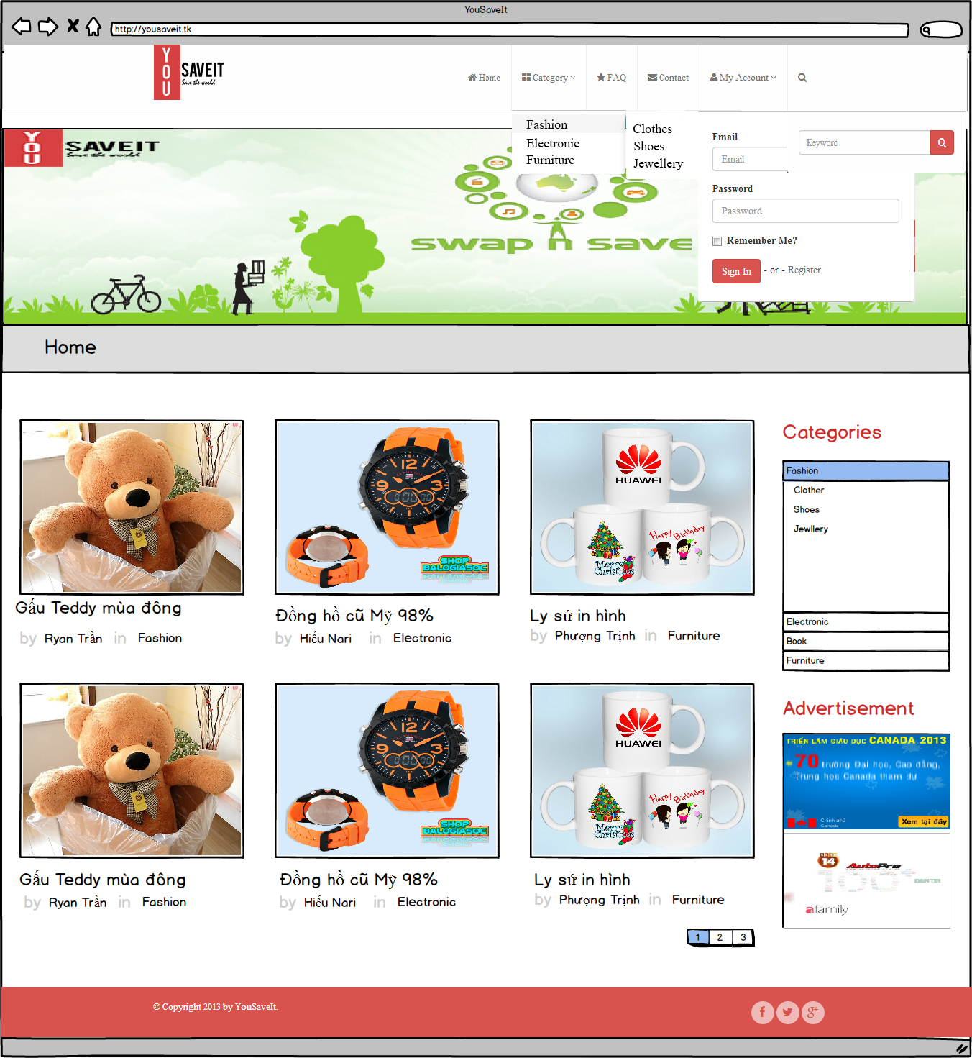
Home page interface
Figure1: Homepage interface

Table 1: Detail description Homepage interface
Homepage Interface |  |  | Code: ID01
No. | Field Name | Type | Target | Comment
1 | Home | Link | Direct to the homepage page
2 | Category | Link | “Category popup” will display when click on “Category” link | “Category popup” includes all category in table category on database
3 | FAQ | Link | Direct to the FAQ page
4 | My account | Link | “Login popup” will display when click on “My account” link
5 | Search | Link | “Search form” will display when click on “Search” link
6 | Slider | Slider | Slide the image banner | Picture will slide each 30s
7 | Category | Container | List all category in database
8 | Advertisement | Container | Display banner for ad | Slide up
9 | Footer | Container | Link to social network : Facebook, Tweeter, Google+

Login interface
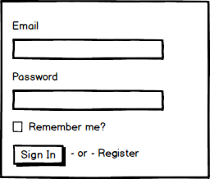

Figure 2: Login interface
Table 2: Detail description login interface
Login interface |  |  |  | Code: ID02
No. | Field Name | Type | Null/ Not null | Target | Comment
1 | Email | Label |  | Text for guide | Color = black Font size =16
2 | Email | Textbox | Not Null | User input their username on it | Size: 260x30px
3 | Password | Label |  | Text for guide | Color = black Font size =16
4 | Password | Textbox | Not Null | User input their password on it | Text mask Size: 260x30px
5 | Remember me | Label |  | Text for guide | Color = black Font size =16
6 | Remember me | Checkbox |  | Save user account
7 | Register | Button |  | Direct to register form
8 | Login | Button |  | Check email and password are correct  - If they are valid login success occur  - Else, system will display an error message

Login success interface
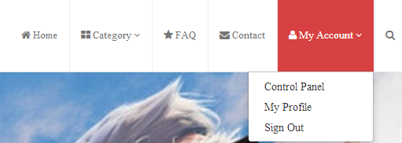
Figure 3: Login success interface

Table 3: Detail description login success interface
Login success Interface |  |  | Code: ID03
No. | Field Name | Type | Target | Comment
1 | Control Panel | Link | Direct to the user control panel
2 | My profile | Link | Direct to the user profile
3 | Sign out | Link | Logout of website and direct to homepage

Register interface
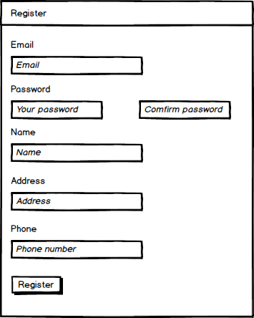
Figure 4: Register interface
Table 4: Detail description register interface
Register interface |  |  |  | Code: ID04
No. | Field Name | Type | Null/ Not null | Target | Comment
1 | Register | Field set |  | Text for guide | Color = black Font size =16
2 | Email address | Label |  | Text for guide | Color = black Font size =16
3 | Email address | Textbox | Not Null | User input their email address on it | Size: 260x30px
4 | Password | Label |  | Text for guide | Color = black Font size =16
5 | Password | Textbox | Not Null | User input their password on it | Text mask Size: 260x30px
6 | Confirm password | Textbox | Not Null | User input their password on it. And it must be match with “Password” textbox | Text mask Size: 260x30px
7 | Name | Label |  | Text for guide | Color = black Font size =16
8 | Name | Textbox | Not Null | User input their name on it | Text mask Size: 260x30px
9 | Address | Label |  | Text for guide | Color = black Font size =16
10 | Address | Textbox | Not Null | User input their address on it | Text mask Size: 260x30px
11 | Phone | Label |  | Text for guide | Color = black Font size =16
12 | Phone | Textbox | Not Null | User input their phone on it | Text mask Size: 260x30px
13 | Register | Button |  | Check email, password are valid  - If they are valid create new account  - Else, system will display an error message | Color = Blue

Posting interface
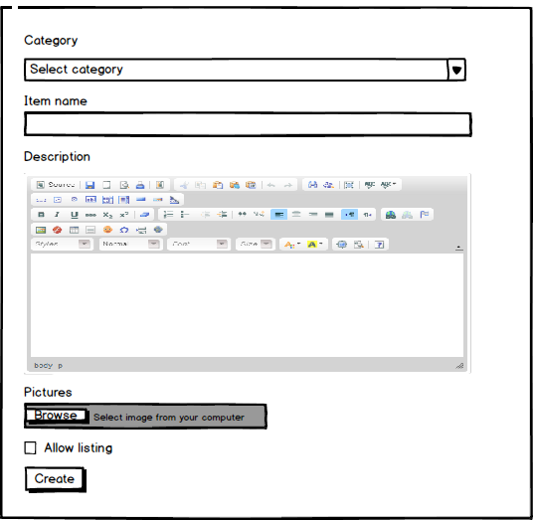
Figure 5: Posting interface
Table 5: Detail description posting interface
Posting interface |  |  |  | Code: ID05
No. | Field Name | Type | Null/ Not null | Target | Comment
1 | Category | Label |  | Text for guide | Color = black Font size =16
2 | Category | Dropdown box | Not null | Display all category on database
3 | Item name | Label |  | Text for guide | Color = black Font size =16
4 | Item name | Textbox | Not Null | User put item name of their topic
5 | Description | Label |  | Text for guide | Color = black Font size =16
6 | Description | Container | Not null | User put description of their topic | Use ckeditor to enhance text
7 | Thumbnail | Label |  | Text for guide | Color = black Font size =16
8 | Thumbnail | Container | Not null | Upload image from user’s computer
9 | Allow listing | Checkbox |  | If checked it will display this topic in homepage
10 | Create | Button |  | Check all field if valid then post topic on database

Posting detail interface

Posting detail interface – Their own topic
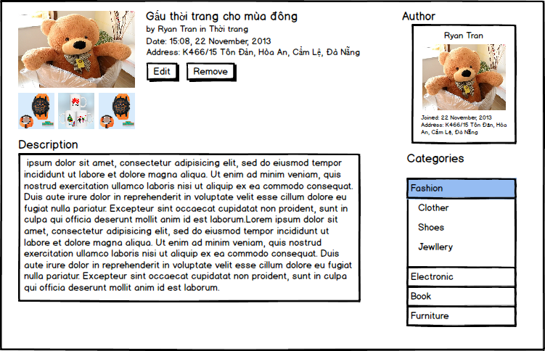
Figure 6: Posting detail interface

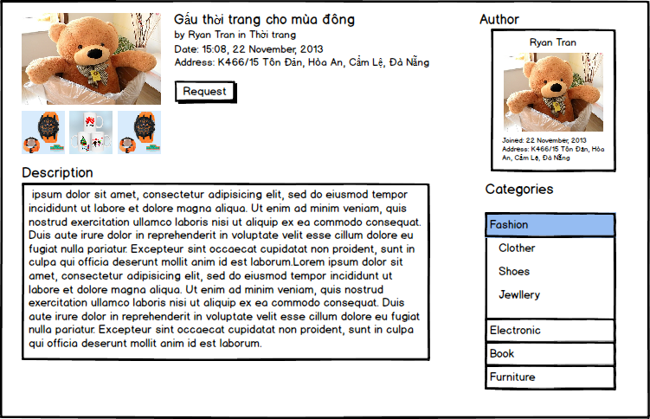
Posting detail interface – Not their own topic
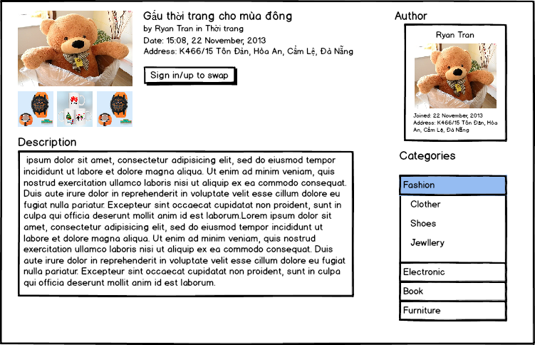
Figure 7: Posting detail interface – No their own topic

Posting detail interface – Not login
Figure 8: Posting detail interface – Not login yet

Table 6: Detail description Posting detail interface
Posting detail Interface |  |  | Code: ID11
No. | Field Name | Type | Target | Comment
1 | Author | Container | Display author name, date join website and address
2 | Topic detail | Container | Display information about topic | Includes thumbnail image, the title, trader name, date of the topic and address for trade
3 | Description | Container | Display the content of the topic
4 | Edit | Button | Display form edit topic
5 | Remove | Button | Delete topic
6 | Request | Button | Display request form
7 | Sign in/up to swap | Button | Display Login/ Register form

Topic management detail interface
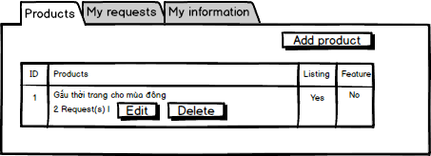
Figure 9: Posting detail interface
Table 7: Detail description Topic management interface
Posting detail Interface |  |  | Code: ID11
No. | Field Name | Type | Target | Comment
1 | Product | Tab selection | Display all topic of user
2 | Add product | Button | Direct to posting form
3 | Edit | Button | Direct to edit posting form
4 | Delete | Button | Delete topic chosen
5 | “Gấu thời trang..” | Label | The title of topic
6 | 2 request | Label | The number of request in this topic

Appendix A: Approval
Prepared by | Signature | Date
Tran Cong Binh
K16CMU-TTT
Approved by | Signature | Date
Tran Kim Sanh
Mentor
Duy Tan University

Nguyen Trinh Trung Duong
Mentor
Duy Tan University

